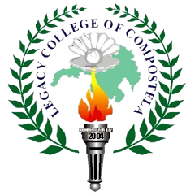 | LEGACY COLLEGE OF COMPOSTELA  Dagohoy Street, Poblacion, Compostela, Davao de Oro  “Quality Education Within Reach”  INSTITUTE OF INFORMATION TECHNOLOGY (IIT)  School Year 2025-2026 | 
Capstone Defense Meeting Minutes
1. MEETING DETAILS
DATE | DEFENSE |  | START TIME |  | END TIME
 | Title
CAPSTONE TITLE

2. REVISION ITEMS
# | DEFENSE ITEMS | PANEL MEMBER | ACTION TAKEN | DECISION  (PROVIDED BY PANEL)
01
02
03
04
05
06
07

3. APPROVAL AND SIGNATURES
PANEL MEMBER NAME | SIGNATURE with date
<ADVISER NAME>
JOVITO BOLACOY, MIS
GLENDELL JADRAQUE, MIS
JOHN LOUIS D. MERCARAL, MIS

